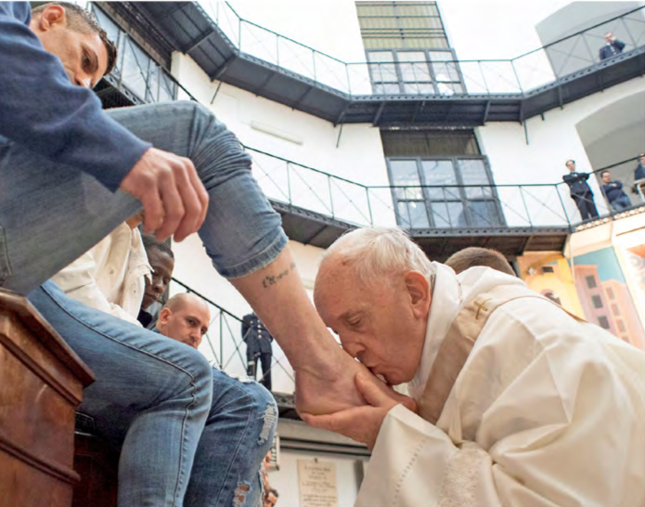



Student Plenary Assembly Student Guide

How is God calling us to be a Christ-centred church that is:

HUMBLE,

HEALING AND

MERCIFUL

How is God calling us to be a Christ-centred Church that is:

HUMBLE, HEALING AND MERCIFUL

People spoke about many different topics in Phase 1: Listening & Dialogue. A comprehensive report on all the voices of the participants is available at: <https://plenarycouncil.catholic.org.au/resources/reports/#snapshotreports>

TOPICS: WHAT DID PEOPLE TALK ABOUT?

Below are some of the topics that informed this particular theme, which was created through a combination of analysis, discernment and prayer.

Allow contraception, birth control • Baby Boomer generation to listen to young Catholics • Be a witness in society • Better communication of what the Church does • Better homilies • Better implementation of Royal Commission recommendations • Better training and support for youth leaders • Call to repentance for clergy sexual abuse • Care for neighbour • Care for the environment • Care for the family • Defend right-to-life issues • End clericalism • End discrimination of LGBTQ • Establish more youth programs • Fight for human rights issues • Focus on new evangelisation • Greater access to Mass and Reconciliation • Greater concern for victims and survivors • Greater connection with and inclusion of Indigenous Australians • Greater emphasis on prayer and sacraments • Greater focus on Jesus Christ • Greater focus on the Word of God • Greater leadership from bishops • Greater leadership from priests • Greater trust, faith and hope in God • Healing liturgies and public signs or acts of reparation for clergy sexual abuse • Inclusion of the divorced and remarried • Listen to one another more • Mass to be more appealing to youth and children • More transparency and accountability regarding clergy sexual abuse • More welcoming parishes • New translation of the Mass (inclusive language) • Outreach to all the baptised • Outreach to the wider community • Outreach to youth • Reduce margins between rich and poor • Special care of rural parishes • Youth to be involved more in Church community

*\*please note this is a section of the topics raised during the Listening and Dialogue phase that engaged over 220,000 people across Australia. For more information on the report and topics please visit:* <https://plenarycouncil.catholic.org.au/resources/reports/#snapshotreports>

WHEN THINKING ABOUT A CHRIST-CENTRED CHURCH:

What does “humble” look like, sound like and feel like to you?

What does “healing” look like, sound like and feel like to you?

What does “merciful” look like, sound like and feel like to you?